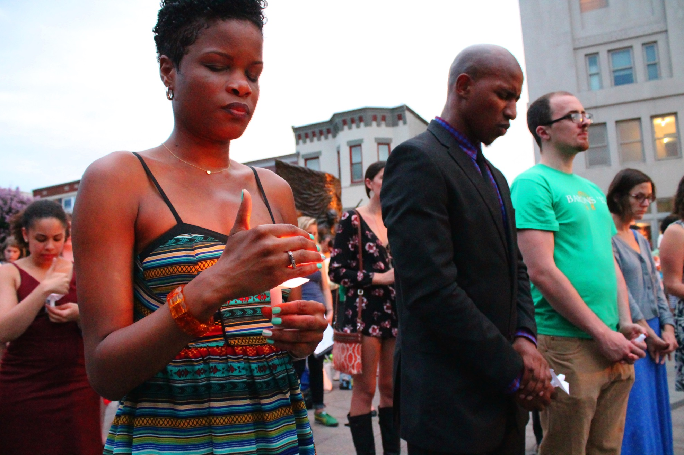
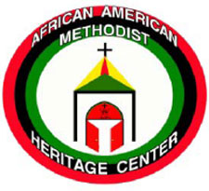
December 2015
Journal of the African American Methodist Heritage Center
AAMHCJournal
Now More than Ever By Gil Caldwell
Events at Emmanuel African Methodist Episcopal Church in Charleston, S.C. on June 17, 2015 in which Dylan Roof, a young white man, killed and wounded members of this historic black church remind us that we continue to be engaged in a full-blown battle against evil forces. These crises are a strong reminder of why one mission of the African American Methodist Heritage Center (AAMHC) is to keep a record and tell the story of the journey of blacks, particularly black Methodists, in the development of the Methodist Church and the United States of America.
George Santayana wrote in The Life of Reason, published in 1905, that “Those who cannot remember the past are condemned to repeat it.” The reluctance of some whites and blacks to remember publicly the history of attitudes and actions of anti-black racism in our churches and society encourages smoldering embers of hate to flare up and wreak their damage. Even today, in the year 2015, we still experience the destructive behaviors of previous centuries. We find old mementoes from yesterday, like the Confederate battle flag, stoking angry hearts and minds.
I recall that sixty years ago, I visited the Divinity School of Duke University seeking admission. My hope was that the Methodist Church that once denied black attendance or full participation would recall its history of racial segregation. It would ask itself what biblical authority, interpretative theology, or Christian understanding justifies the rejection of blacks by whites. It did not happen. When do we begin to create the “teaching moments” that re-shape and reform our anti-black attitudes and actions?

All United Methodists, no matter their face or ethnicity, are called to cease engaging in the silence, denial and revisionism about the negative past of Methodist history. Let us not engage in the pretense than the merger in United Methodism of the black Central Jurisdiction in 1968 produced a post racial/racist society. It didn’t. While progress has been made , there are still churches where the presence of blacks is non-existent although they are visible in the surrounding community. There are still churches in which black/white relationships are addressed through “special collections.” We need to visit the record of the past told in such works as the film “Richard Allen, Apostle of Freedom.” This cinematic portrayal depicts how Richard Allen was so affected by the racism and insensibility of the church that he left and organized his people into the African Methodist Episcopal Church. We need to also consider the often painful contributions of those blacks who remained. in the mainstream Methodist Episcopal Church to seek direct partnership with its wary white members… CONTINUED NEXT COLUMN

In this time of racial upheaval, the African-American Methodist Heritage Center (AAMHC) needs financial support more than ever, not just from the denomination, but also from local churches. The AAMHC supports our enlightenment, exposes our treasured memories, and counters the voids that surface about the roles played by blacks and whites in the denomination’s growth. It is time to make black history, religion and spirituality major cornerstones of the 21st century United Methodist Church. This is a vital part of “transforming” the world.

Gil Caldwell, the author, is a retired elder and member of the Rocky Mountain/Denver Conference. A self-described “footman in the U.S. civil rights movement” he serves on the Board of the African-American Methodist Heritage Center and can be reached at
caldwellchurch@aol.com.
NOW MORE THAN EVER

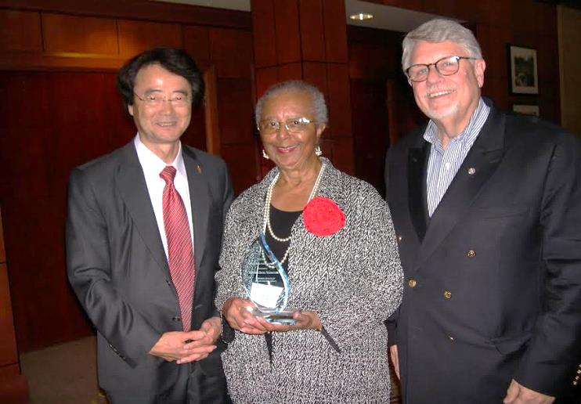
AAMHC ASKS:
What You Said

Image courtesy of GCAH.

During the month of August 2015, the Board of Trustees of the African American Methodist Heritage Center sent out an online survey to our constituency to gather information about how effective our ministry and communications have been with you over the last several years. We asked a series of 8 questions. We believe you were candid, and at the same time supportive, in your responses. We are grateful to all of you who took the time to respond. Overall, we found that we are quite effective in some areas, while we need to make improvement in others.
This past summer the 8th Historical Convocation of the General Commission on Archives and History (GCAH) , the Methodist Historical Society (MHS), The North Central Jurisdiction Commission on Archives and History (NCJAH) and the host Northern Illinois Conference Commission on Archives and History (NICAH) met at Garrett Evangelical Theological Seminary in Evanston, Illinois. The global delegation to this meeting came from such far reaching places as Russia, Hungary, and Africa.
At the dinner banquet of GCAH, the president of the African American Methodist Heritage Center (AAMHC), Barbara Ricks Thompson received the Distinguished Service Award. In addition to the above delegation, close friends and AAMHC board members were present. Bishop Jeremiah Park of the Susquehanna Episcopal Area and Rev. Fred Day, General Secretary of GCAH, presented the award. Ms. Thompson was introduced by Bettie Lusk, GCAH member and wife of AAMHC board member, Donald Lusk.
The Distinguished Service Award is given annually in recognition of the significant contribution to the ministry of memory of the United Methodist Church to a person, group, institution or church (es). Past recipients of the award have included Rosemary Skinner Keller, Russell E. Rickey, J. Gordon Melton, and Historic St. George’s UMC Church and Mother Bethel AME Church, Philadelphia for the efforts to heal the wound of the 1787-1792 years of separations. The first award was given in 1991.
Ms. Thompson chose in her acceptance of the award to acquaint those present of the path AAMHC has traveled since the General Conference of 2000 gave it a start as a result of legislation presented by Black Methodist for Church Renewal (BMCR). She told of the recognized need to preserve and highlight the contributions of African Americans to Methodism, and plans for a oral history project.. The Board of Trustees of the African American Methodist Heritage Center salute Ms. Thompson and thanks her for her years of outstanding leadership and service to the organization.
Bettie Lusk, the author, can be reached at
dandlusk@prodigy.net.
.

Distinguished Service
You highlighted our need for greater communicating and publicity. There were some very positive responses and then there were negative ones. All of the responses will serve to direct us and to sharpen our strategies more as we seek to serve you better.
Some of you were not even aware of our existence, and more than 75% said that you do not currently provide financial support, and 38% said you would consider doing so. Interestingly, 90% of you want more programs and resources promoting historical and current contributions of African Americans in Methodism.
Too many, 30%, did not remember receiving email or a journal from AAMHC. Since the bulk of our mailing list is provided by National BMCR (Black Methodists for Church Renewal) and through contacts made at workshops conducted by AAMHC, some postal addresses and email addresses are outdated. We could certainly use your help to collect emails or addresses of friends and contacts in your local area.
Your responses also shown that 63% of you prefer to receive communication from AAMHC and 12% would like to receive a printed newsletter. We would like to be able to be in touch with you, so please send names of friends, churches or organizations to receive updates on a regular basis. Please email your information to aamhc@aol.com or send by postal mail to AAMHC, Attn: Carol Travis, 36 Madison Ave P.O. Box 127, Madison, NJ 07940. Questions may be directed to Ms. Travis on 973-408-3862.
Donald Lusk, the author, is a member of the AAMHC Board and can be reached at dandblusk@prodigy.net.
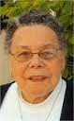
.
SAVE THE DATE
SATURDAY, FEBRUARY 27, 2016
OPEN HOUSE & DEDICATION IN MEMORY OF
BISHOP LEONTINE T. C. KELLY
950 South Beach Blvd. Waveland, MS
Bishop Leontine T.C. Kelly, a daughter and wife of ministers, was the first African American woman bishop in a major Christian denomination when she was elected as bishop in the United Methodist Church in 1984. She was a friend and mentor to many, and was a social and political activist who supported many issues related to the rights of all people. Bishop Kelly, the mother of Angella Current Felder, a member of the Board of Trustees of the African American Methodist Heritage Center (AAMHC), died on June 28, 2012 at age 92. For additional information contact Mollie Stewart, President and CEO, Gulfside Association at 228-341-0324 (c) or at gulfsideum@att.net.

Bishop Leontine T.C. Kelly, a daughter and wife of ministers, was the first African American woman bishop in a major Christian denomination when she was
elected as bishop in the United Methodist Church in 1984. She was a friend and mentor to many and was a social and political activist who supported many issues related to the rights of all people. . Bishop Kelly, the mother of Angella Current Felder, a member of the Board of Trustees of the African American Methodist Heritage Center (AAMHC), died on June 28, 2012 at age 92. For additional information contact Mollie Stewart, President and CEO, Gulfside Association at 228-341-0324 (c) or at gulfsideum@att.net.

BOARD MEMBERS &
Friends on the Move
Friend of the Board, Rev. Dr. Henry Masters and Closer Walk Ministries have released the inaugural issue of By Faith Magazine. The publication is a bi-monthly magazine celebrating the gifts and ministry of black United Methodist Churches and dedicated to the legacy of Harry Hosier. Contact cw@byfaithmagazine.com... Dr. Jacqui King, wife of Donel King, member of the AAMHC Communications Committee, has accepted a position as Director, Leadership for Congregational Vitality at Discipleship Ministries in Nashville, TN… Carol Travis, Executive Assistant to the Board of Directors, AAMHC is featured in a DVD produced for the 200th Anniversary of Foundry UMC in Washington, DC celebrating the shared ministry of Asbury UMC and Foundry. Travis and Ralph Williams of Foundry co-chaired the Foundry and Asbury: Race and Reconciliation Ministry Team. The DVD produced by the award winning, John Coleman, is available for purchase by contacting Travis at carol6303@aol.com... Dr. Leonard Haynes, senior director of Institutional Services for the Office of Postsecondary Education at the U.S. Department of Education and also a member of the AAMHC Development Committee recently received the Ohio State Alumni Association’s University Diversity Champion Award. He is the first ever recipient of the award which recognizes an alumnus who has dedicated sustained leadership, their time and their talent to the university… Friend of the Board, Rev. Rupert Hall, the Pastor of Groveville, UMC in Greater New Jersey, was recently the recipient of the One Matters Award, a new award given to a church in each conference that is turning zeros into positive numbers with a renewed focus on discipleship. The award, originated from Discipleship Ministries of the United Methodist Church, carries an award of $1000 and a plaque. GrovevilleUMC has had a 20% increase in attendance for the past two years, and paid 100% of its shared ministries for the first time in six years in 2014. Hall has been at the church for two years… Dr. Elaine Parker Adams, a member of the AAMHC Communications Committee just received the J.C. Montgomery Child Safety Award of 2015 from the Texas Office for Prevention of Developmental Disabilities and the Executive Committee. This award recognizes the extraordinary people and organizations in Texas for their tireless and exemplary work to keep children safe.
contribution for 2015). There are a couple of ways to support this ministry:
1) You may give through the United Methodist Advance: www.umcmission.org. Look for the Advance and input our name, African American Methodist Heritage Center, or Advance #302051.
2) You may give directly by writing a check made out to AAMHC to: AAMHC, 36 Madison Avenue, P.O. Box 127, Madison, NJ 07940.
Your contribution will help us to continue our ministry and especially to expand our Oral History Project which is trying to recover the life experiences of some of the African Americans who lived and worked through the transition of Methodism from the time of the segregated Central Jurisdiction into the geographical jurisdictions. Also, you will help make it possible for the Heritage Center to be more available to work with annual conference and local church efforts to enhance the recovery, preservation and promotion of the role of African Americans in the rich history of Methodism. - Barbara Ricks Thompson, President, Board of Trustees, can be reached at beerix@aol.com.

It’s Almost 2016
For some persons it is a time to hang lights and put up Christmas trees. For some people it is a time to share delicious meals and renew friendships. For many persons it is also a time for gift-giving and remembering friends and family. Honor friends and loved ones by making an end-of-year financial contribution to support the ministry of the Heritage Center. (It must be post-marked by December 31, 2015 to be an eligible

WHAT’S YOUR
Call Story?
The Office of Communications of the General Board of Higher Education and Ministry (GBHEM) is pleased to announce the launch of MyCallStory.org. This new site is designed to encourage United Methodists around the world to share their story of ministry through short videos. AAMHC encourages it’s constituency to participate in order to ensure that the rich history of African American Methodists are included in this initiative. Select videos will be featured at General Conference, on various websites or shared via social media channels. For more information contact Ms. Ebony Lincoln, Director of Communications, GBHEM, 615.340.7382, elincoln@gbhem.org or at www.gbhem.org.
AAMHC
36 Madison Avenue,
P.O. Box 127
Madison, NJ 07940

By Elaine Parker
Adams
The Epworth League, named after John Wesley’s village of Epworth in England, was the major young adult association of the Methodist Episcopal Church at the turn of the 20th century. The League emphasized self-betterment for young adults and provided them with tools for addressing social issues. The League was so popular that by 1925, Texas alone had 40,000 members. Methodist Church historian Olin Nail notes that “Perhaps no other similar movement in Methodism influenced so many at such a formative period of life as [the Epworth League] did.”
A predecessor of the Methodist Youth Fellowship (MYF), the Epworth League was an active service organization for youth from approximately 1890 until 1940. The League was co-ed, unlike the gender-separated Sunday schools of the era. While the members of the Senior Division ranged from 18 to 35, the League also had Junior and Intermediate Divisions for children and younger teens. The League aimed to get young Methodists involved in good works and train Christian soldiers for the ministry. One group described it as preparing for “Churchmanship.”
The pathway for blacks in the Epworth League was not always smooth. In 1895 Missouri Methodists expressed concern that “to admit the colored branches would destroy the plans of the league.” The Texas Christian Advocate reported in 1897 that “Things have come to a pretty pass when a congregation of young Christian people cannot meet without having the negro (sic) obtruded upon it.” However, over the years, attitudes changed, and African Americans played significant roles in the Epworth League, helping individual churches and the community at large. The histories of local black Methodist churches mention the Epworth League as a prominent element of their past.
“Leaguers” impacted their communities in many ways. The first public library in Colo, IA, was started by “Leaguers.” They collected books from the community in red wagons and assembled and operated the library in the city hall. In Sherman, TX, “Leaguers” raised funds to add buildings to Key Memorial United Methodist Church in 1912. The talented young people produced and presented a touring play on temperance. Debates, often on political topics, were encouraged intellectual exercises. The Epworth League in Frederick, MD conducted a well-attended public debate in 1902 opposing the enactment of “Jim Crow” laws re-segregating transportation.
The African American Methodist Center
The African American Methodist Heritage Center is a ministry related to the United Methodist Church. It views the church and its ministry in retrospect and prospect. The AAMHC seeks to learn and appropriate the past as informant and bridge to a more faithful and effective future. It envisions its work as gatherer and conserver of the vital history and heritage of Black people in the successive Methodist bodies from the Methodist Episcopal Church, to being racially segregated in the Central Jurisdiction to the United Methodist Church in the American and global society. Recognition of both the struggle and contributions of African Americans has ebbed and flowed over the past approximately 275 years. The AAMHC ministry is to help ensure that accurate representation of that story is preserved and examined. Board of Trustees: Rev. Dr. Gilbert Caldwell, Ms. Angella Current Felder, Rev. Fred Day, Rev. Dr. James Ferree, Rev. Dr. John Heyward, Rev. Rita Howard, Ms. Ruth Lawson, Ms. Cecelia Long, Dr. Cynthia Bond Hopson, Mr. Donald Lusk, Rev. Dr. Walter McKelvey, Dr. Arnold Parks, Rev. Dr. Cornish Rogers, Dr. James Shopshire, Bishop Forrest C. Stith, President Emeritus, Ms. Barbara Ricks Thompson, Dr. Cheryl Walker, Dr. John Wright, Rev. Dr. Joseph Wilson, Executive Assistant Ms. Carol Travis. The AAMHC Journal is published several times a year by the African American Methodist Heritage Center; AAMHC, 36 Madison Avenue, P. O. Box 127; Madison, NJ 07940. E-mail: aamhc@aol.com; www.AAMHC-UMC.org; (973) 408-3862. Advance #3020514.

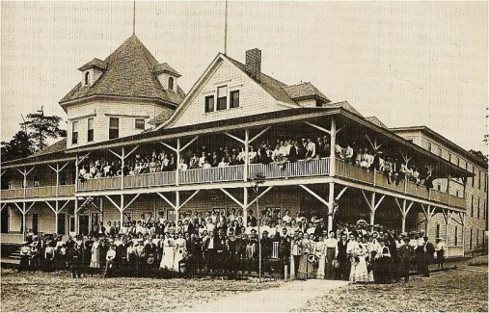
Youth ministry advocate J. Warren Smith writes that “Leaguers” also spoke out against poor houses, visited prisons, opposed lynching, and aided families of victims. The League was considered important enough in the religious development of African American youth that Methodist-affiliated campuses expected residential students to attend campus Epworth League meetings, according to Daniel Sims, author of “Religious Education in Negro Colleges and Universities.”
THE EPWORTH LEAGUE
Revisited
Today there is a revival of the Epworth League in the UMC at a time when the active presence of young adults in the churches is critical. The Pew Forum on Religion and Public Life reports that millennials are considerably less religious than older Americans. Many are unaffiliated with any faith. Often, among Methodist youth, attention to church and MYF drifts when they graduate high school. The revived Epworth League, a Methodist-sponsored global organization, devotes its attention to these youth, focusing them on community building, missions, and spiritual growth.
Based on many elements of the original Epworth League, the current League lists its website as www.epworthleague.org. Information is also posted on the League’s Facebook page. Ken Rheingans, the League Director, and his staff steadily work on the League’s development, promoting youth retreats, summer missions, and Bible School day camps. Perhaps because the home base is in Wisconsin, there seems to be a more rural, than urban emphasis. The League’s social activism beyond ecological projects and mission trips needs more definition.
The Epworth League Institute helps churches establish programs providing training in work readiness, entrepreneurship, parenting and outreach to prison ministry. While these are worthy activities, the Institute leaders are urged to seek and embrace advice from the wise elders of the Methodist church, particularly individuals of color, who possess broad awareness of issues related to social consciousness. Economic justice, excessive incarceration, homelessness, voting rights, educational equality, neighborhood violence & hate crimes should be added to the community activist agenda.
Elaine Parker Adams is the author of “The Reverend Peter W. Clark: Sweet Preacher” and “Steadfast Reformer” and is a member of the AAMHC Communications Committee. She can be reached at epadams@aol.com.

