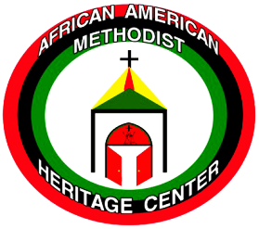
Volume 2, 2016
AAMHC at a Glance
The African American Methodist Heritage Center is a ministry related to the United Methodist Church. It views the church and its ministry in retrospect and prospect. It envisions its work as gatherer and conserver of the vital history and heritage of Black people in the successive Methodist bodies of the Methodist Episcopal Church, to being racially segregated in the Central Jurisdiction to the United Methodist Church in the American and global society. The AAMHC ministry is to help ensure that accurate representation of that story is preserved and examined. Board of Trustees: Rev. David W. Brown, Dr. Angella Current Felder, Rev. Fred Day, Rev. Dr. James Ferree, Rev. Dr. Hilly Hicks, Dr. Cynthia Bond Hopson , Ms. Ruth Lawson, Ms. Cecelia Long, Mr. Donald Lusk, Rev. Dr. Walter McKelvey, Dr. Arnold Parks, Dr. James M. Shopshire, Sr., Ms. Mollie M. Stewart, Bishop Forrest C. Stith, President Emeritus, Dr. Barbara Ricks Thompson, Dr. Cheryl Walker, Ms. Anne Fleming Williams, Member Emeritus, Dr. John Wright, and Carol L. Travis, Executive Assistant. The AAMHC Journal is published several times a year by the African American Methodist Heritage Center; AAMHC, 36 Madison Avenue, P. O. Box 127; Madison, NJ 07940. E-mail: aamhc@aol.com; www.AAMHC-UMC.org; (973) 408-3862. Advance #3020514.The AAMHC Journal is published several times a year by the African American Methodist Heritage Center; AAMHC, 36 Madison Avenue, P O. Box 127; Madison, NJ 07940. aamhc@aol.com,
www.AAMHC-UMC.org;
(973) 408-3862. Advance #3020514.

The Global Church: A New Reality
By Retired Bishop Forrest C. Stith
Bishop Stith is President Emeritus of the African American Methodist Heritage Center (AAMHC). This article also appeared in the UM Connection of the Baltimore Washington Conference, Volume 27, Issue 10. A full text of his comments can be found at www.aamhc-umc.org.)
At the 2016 General Conference in Portland, Ore., for the first time, United Methodists experienced a new reality -- what it means to be a global church. Some people commented on the presence of spontaneity, passion, evangelistic fervor and vitality offered by churches from Africa and the Philippines. European delegates with their multiple language skills and unique perspectives of the church were helpful as well.

It was reported that this year 44% of the General Conference body came from the Central Conferences. My wife and I have spent much of our adult life working and praying for the reality of a global church. But beyond the euphoria of a great and diverse fellowship, I feel compelled to raise some questions.

Can we afford the current model?
One of the primary escalator of costs for the denomination is the attempt to evolve from an American church with global partners to a fully participatory global church. Major costs include transportation. At General Conference, the average travel cost for participants outside the U.S. was $3,000/person. Ten languages were spoken. Almost 200 interpreters were needed, along with support staff, and every delegate and bishop was required to use equipment for simultaneous translation. The cost was an astronomical $2.3 million.

How do logistics relate to cost factors?
There is an underlying assumption that to be a global church, all of the continents should mimic what happens in the church in the U.S. This leads to challenges. For instance, while Americans take travel for granted, in much of Africa public transportation is limited and erratic. Communication systems are also often nonexistent or fragile. It is therefore difficult for Central conferences to operate committee meetings, such as a College of Bishops, episcopacy committees or executive committees. There is also the practical reality of periodic threats of violence or international diplomatic issues that limit visas and travel. …Continued page 2

AAMHC Journal
A Journal of the African American Methodist Heritage Center
At the 2016 General Conference in Portland, Ore., for the first time, United Methodists experienced a new reality -- what it means to be a global church. Some people commented on the presence of spontaneity, passion, evangelistic fervor and vitality offered by churches from Africa and the Philippines. European delegates with their multiple language skills and unique perspectives of the church were helpful. And, interestingly, It was reported that this year 44 percent of the body came from the Central Conferences. My wife and I have spent much of our adult life working and praying for the reality of a global church. But beyond the euphoria of a great and diverse fellowship, I feel compelled to raise some questions.

Can we afford the current model?
One of the primary escalations of costs for the denomination is attempting to evolve from an American church with global partners to a fully participatory global church structure. Major costs include transportation. At General Conference, the average travel costs for participants outside the U.S. was $3,000 per person.

Ten languages were spoken at the General Conference. Almost 200 interpreters were needed along with support staff. In addition, every delegate and bishop was required to use equipment for simultaneous translation. The cost was astronomical, exceeding $2.3 million.

How do logistics relate to cost factors?
There is an underlying assumption that to be a global church, all of the continents should mimic what happens in the church in the U.S. This leads to challenges. For instance, while Americans take travel for granted, in much of Africa, public transportation is limited and erratic. Communication systems are also often nonexistent or fragile. It is therefore difficult for Central conferences to operate committee meetings, such as a College of Bishops, episcopacy committees or executive committees. There is also the practical reality of periodic threats of violence or international diplomatic issues that limit visas and travel.

The paradox is that while churches in Africa and the Philippines are growing the fastest, they are limited in their financial ability to support existing congregations, undergird growth & implement global structures. Churches in the U.S, which are alternately losing members and resources,

NOW MORE THAN EVER

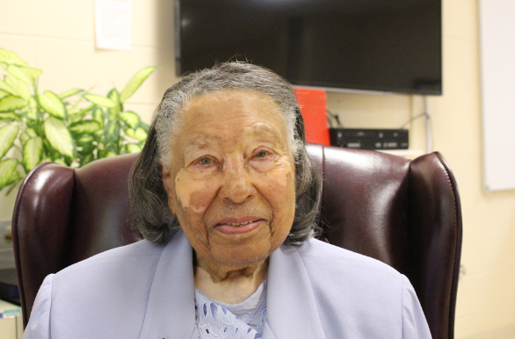
The paradox is that while churches in Africa and the Philippines are the fastest growing, they are limited in their financial ability to support existing congregations, to undergird growth, and implement global structures. The conundrum is that churches in the U.S, which are losing members and resources, are placed in the untenable position of providing increased financial support. This can create even more decline.
What does it mean to be “inclusive?”
We need to redefine inclusiveness. In an attempt to be inclusive, the General Church uses the formula of proportional participation based on numbers of constituents as the only criteria. In the U.S., for more than 40 years, we prided ourselves on an inclusiveness model based on diversity of language, ethnicity, culture and geography -- not numbers. The ramifications are major. Left off the table of decision-making are large segments of the denomination who lack numbers but bring unique and differing perspectives.
The African American Methodist Heritage Center (AAMHC) is establishing an oral history library to recover and preserve the stories of African American lay and clergy Methodists who were active beyond the local church during the period of the Central Jurisdiction and its subsequent merger with the geographical jurisdictions. We stand on the shoulders of those men, women, (such as Mrs. Ruth Thomas, widow of Bishop James S. Thomas, pictured above), and youth who worked during that era. We are the heirs of their perseverance, ingenuity, strategies, commitment and faith.
AAMHC needs from you information about those leaders such as conference staff, district superintendents, general agency staff and members, youth staff, etc. because we want to interview them while they are willing and able to share their perspectives. These “founts of wisdom” are in each jurisdiction and probably in each annual conference. Remember, when an elder passes, a library perishes. Please contact Carol Travis, Executive Assistant, and provide the names, addresses, phone numbers and e-mail addresses of persons who should be included in this collection of information. You may reach Carol at the telephone number and e-mail address below.
Share your legacy with the United Methodist Church through The
African American Methodist Heritage Center (AAMHC): 36 Madison Avenue • PO Box 127 • Madison, NJ 07940 (973) 408-3862
aamhc@aol.com • aamhc-umc.org
Advance Code 3020514

Oral History And You

Meanwhile, small churches in rural or impoverished areas of the U.S. are expected to give sacrificially in order to support a global church, which may in turn set priorities and make the decisions for their ministry without their involvement. Perhaps we need to review what a board might need to be from a global perspective and incorporate regional sub-committees.
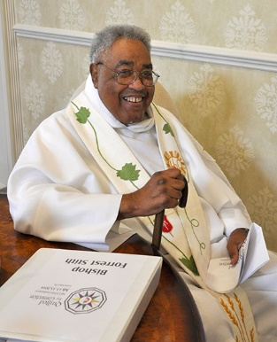
During the racist days of the Central Jurisdiction, most African-American churches proudly paid their full apportionments, which were often based on membership, not financial viability. Remember, most black communities have historically received income at one-half the income median of white America. But these churches perceived that paying a full share was the reality of full participation and equality.

The General Council on Finance and Administration (GCFA) recently introduced a formula for Central Conference churches to contribute more equitably, but it will not compare with Jurisdictional giving.
Retired Bishop Forrest C. Stith, reflected upon the 2016 General Conference. Reach him at fcpreach@aol.com.

Autonomy or Accountability?
Many American churches are deeply involved in mission support and funding, but they do not always find that the funds raised for Africa are used appropriately. In a few instances, some of the newer conferences have serious financial issues. In at least one African conference, even GCFA and GBGM (General Board of Global Ministries), after several audits, were unable to gain restitution for missing funds or accountability of hundreds of thousands of dollars given by U.S. churches. There seems to be no Disciplinary process for global accountability. Can we be global if part of the church is not accountable?

When I visited Africa, I had no doubt that the church was growing rapidly. However, no one was counting, or even knew the names of, many of the attendees. Instead, the pastor estimated the number present in what we used to call “a preacher’s count.” However, the General Church is using these soft statistics to determine representation on boards, agencies, committees and even the General Conference. I would hope that GBGM would offer a membership audit before 2020 to assure correct proportionate representation, before the implementation of new areas and the fair distribution of resources.

How do we address cultural diversity?
To be a global church is to understand that the cultural and governmental systems are very different in a given continent. How does a global church fairly relate to multiple cultural and political styles and issues in its Social Principles or proclamations?

While I lift up a number of questions, my greater concern is that we are not addressing realistically how to be a global church. Do we need a model like the World Methodist Council, or regional bodies with some kind of semi-autonomy?

I’m certain that absolute solutions will not be found in legislative action. We must seek a methodology of living together in a diverse world and diverse church. It would also help to study church history, how the church has survived and thrived amidst divisions of theology, culture, and race. And, as we await what the Lord will do, let us pray that we all may be one in Christ Jesus.

How Much is Five Plus Two?
(Hint: It’s More Than You Think)
The story is told of a fourth grade student who asked his tutor “How many is five plus two”? This irritated the tutor because the student should have known the answer. The tutor answered “you know the answer is seven”. The student replied with a smile, “No in your math five plus two is seven, but not in God’s math. For God, five plus two is more than five thousand because God can feed five thousand people with only five loaves of bread and two fish.” Out of the mouths of children come words of wisdom. But, how do we put words into action?

For the African American Methodist Heritage Center (AAMHC) stretching limited financial resources is a routine endeavor. During the quadrennium 2012-2016 The General Conference of the United Methodist Church granted to AAMHC through the General Commission on Archives and History (GCAH) funding of $35,000 a year. Of that amount $10,000 came from the fund reserves of GCAH; that was a substantial commitment of their limited funds.

The budget approved by the 2016 General Conference for the quadrennium 2017-2020 did not provide any funding for AAMHC. Thankfully, GCAH determined to support the ministry of AAMHC by providing decreasing funding in the amount of $25,000 for 2017, $20,000 for 2018, $15,000 for 2019 and $10,000 for 2020. This represents a significant decrease in sure funding for the new quadrennium which must be made up somehow.

Now more than ever, this ministry of remembrance must rely upon the financial support of persons who care about recovering and preserving the history of African Americans and Methodism. AAMHC must intensify its efforts to develop and nurture financial support for both operational and endowment purposes. It is important that people commit themselves to being regular (annual or monthly) contributors to the ministry. Also, supporters are encouraged to consider AAMHC for inclusion in estate plans so that the ministry will continue into the future – after all, History Marches On. AAMHC is committed to continuing its ministry, including oral history projects, provision of resources and the offering of training opportunities for local church and annual conference leaders interested in recovering and preserving the history of African Americans and Methodism in their localities.

AAMHC is an IRS approved not-for-profit organization so that all contributions are tax deductible. Contributions may be made through the Advance # 3020514. Contributions may be made directly to AAMHC and sent to our office at 36 Madison Avenue, P.O. Box 127, Madison, NJ 07940. If you would like more information, please contact Ms. Carol Travis, Executive Assistant at 973-408-3862 or aamhc@aol.com. Also, visit the web page at aamhc-umc.org.

action took place more than three decades after Bishop Leontine T. C. Kelly, of Virginia, responded to a summons and left the Southeast Jurisdictional Conference to go to the Western Jurisdiction Conference where she was elected as the First African American woman Bishop in the United Methodist Church. Bishop Lewis, who was a District Superintendent in the North Georgia Conference, is assigned as the Bishop for the Virginia Conference.

In the 2016 election processes there were six African Americans elected to the episcopacy. The other persons elected are:
- Bishop Leonard Fairley also was elected by the Southeast Jurisdiction and assigned to the Kentucky and Red Bird Missionary Conferences. He previously was a District Superintendent in the Western North Carolina Conference.
- Bishop Tracey Smith-Malone was elected by the North Central Jurisdiction and assigned to the Ohio East Conference. She previously served as District Superintendent of the Chicago Southern Region of the Northern Illinois Conference.
- Bishop Frank Beard was elected by the North Central Jurisdiction and assigned to the Illinois Great Rivers Conference. He previously served as pastor of Castleton, United Methodist church in Indianapolis, Indiana.
- Bishop Cynthia Moore Koikoi was elected by the Northeast Jurisdiction and assigned to the Western Pennsylvania Conference. She previously served as District Superintendent of the Baltimore Metropolitan District of the Baltimore-Washington Conference.
- Bishop LaTrelle Easterling was elected by the Northeast Jurisdiction and assigned to the Baltimore-Washington Conference. She previously served as a District Superintendent in the New England Conference.
These men and women have accepted the important responsibility of providing both administrative and pastoral leadership for United Methodists in their assigned geographical areas. As General Superintendents of the denomination they are responsible for equipping the members of the denomination for their disciple-making ministry. It is the responsibility of members to support them and to respond in the ministry of building disciples for Christ.

The first African American clergywoman was elected to the United Methodist episcopacy by the Southeast Jurisdiction Conference in 2016 – Rev. Sharma Lewis was elected on the first ballot. This historic
A Milestone Election
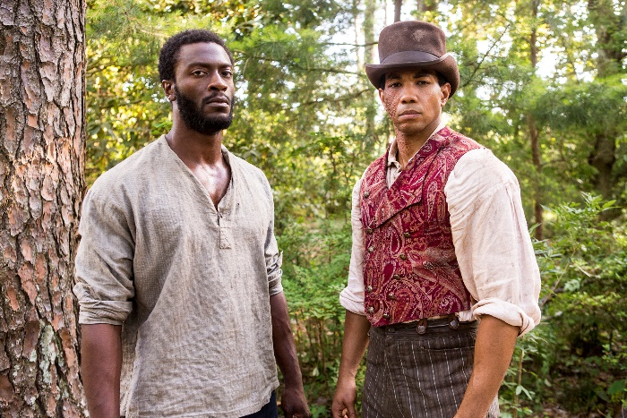
Underground Railroad
By Elaine Parker Adams

John Legend’s video drama series “Underground” has stimulated renewed interest in this vital but mysterious part of the history of American slavery. The term “Underground Railroad” refers to the clandestine nature of the escape routes and the use of railroad terminology as a code language. The Underground Railroad enabled as many as 100,000 slaves to escape the brutal system of enforced servitude in the South and find freedom in northern cities and Canada. Followers of John Wesley were deeply involved as members of the Methodist Episcopal (M.E.), African Methodist Episcopal (AME), British Methodist Episcopal (BME), and Wesleyan Churches. To learn more about the Underground Railroad, there are museums and tours focused on Underground Railroad history located across the country. The following are some with specific links to Methodists:
History & Keeping Informed

To keep up-to-date on activities, you can subscribe to the Underground Railroad Free Press, a widely read independent newspaper covering current programs and projects involving the Underground Railroad and its history. The Press awards prizes for leadership, preservation, and the advancement of knowledge on Underground Railroad issues. A map of Underground Railroad safe-houses and routes in Frederick County, MD is presented in the Press. The newsletter also calendars tours and other events related to the Underground Railroad. For more information, contact: info@urrfreepress.com. The newsletter is free.

It is important for today’s Methodists to be aware of the significant role that the Methodist church played in securing freedom from tyranny for the enslaved. The church continues to fight against contemporary slavery in keeping with its reputation as a “freedom” church.

Elaine Parker Adams is the author of The Reverend Peter W. Clark: Sweet Preacher and Steadfast Reformer. She can be reached at epadams@aol.com.

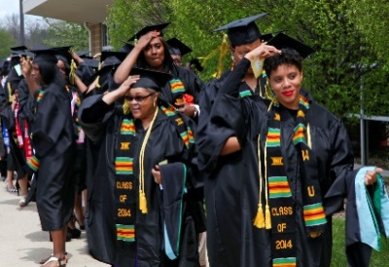
McMillinTours
Sponsors several Underground Railroad tours. From October 27-31, 2016 there will be a tour to the 90th reunion of the town of North Buxton, a haven for escaped American slaves and one of Canada’s most historic black towns. Methodists played a significant role in its development. For more information on tours, contact: stewart@mcmillintours.com.

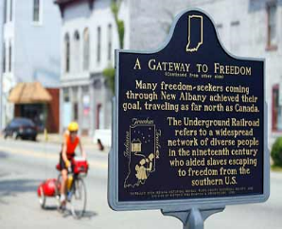Underground Railroad Bicycle Route
Guides you up a 2,007 mile corridor from Mobile, AL to Owen Sound, Ontario, Canada. There are multiple historical stops on the way, but the termination point, Owen Sound, is a special place. Owen Sound’s British Methodist Episcopal Church, a black church also called Zion, was established in 1856. Like other area AME churches, members chose to emphasize British in the name to disassociate themselves from the American slavery issue and protect church members from the drastic effects of the American Fugitive Slave Act of 1850. In 1911, Westside Methodist Church, having outgrown its facility, sold its church building for $1 to the
Signs along the Underground Railroad Bicycle Route from Mobile, AL to Ontario, Canada.

BME Church, an Ontario Heritage site.

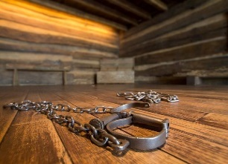Travel Services, Inc. Offers tours emphasizing Underground Railroad sites in the Cincinnati, OH region. Wilberforce University and its Museum are part of the tour. The university was developed on land that included a station of the Ohio Underground Railroad. This tour also features a visit to the National Underground Railroad Freedom Center, a premier educational resource on the history of the Underground Railroad, and an opportunity to see the home of Harriet Beecher Stowe. Contact travelservices@comcast.net to learn more.
Shackles from the slave pen at the National Underground Railroad Freedom Center

Underground Railroad Museum
Flushing, OH has several tours visiting locations where the railroad was active, including black schools, churches, and early communities formed by escaped slaves. One of the museum’s tours includes a visit to Cadiz, a former home of Methodist Bishop Matthew Simpson, spiritual advisor to President Lincoln. The museum itself contains an extensive collection of publications, books, memorabilia and other articles. It also lends a traveling trunk (mobile mini- museum). For more information, contact Dr. John S. Mattox, Curator at curator@ugrrf.org.

